FEATURES |  |  |  |  |  |  |  | 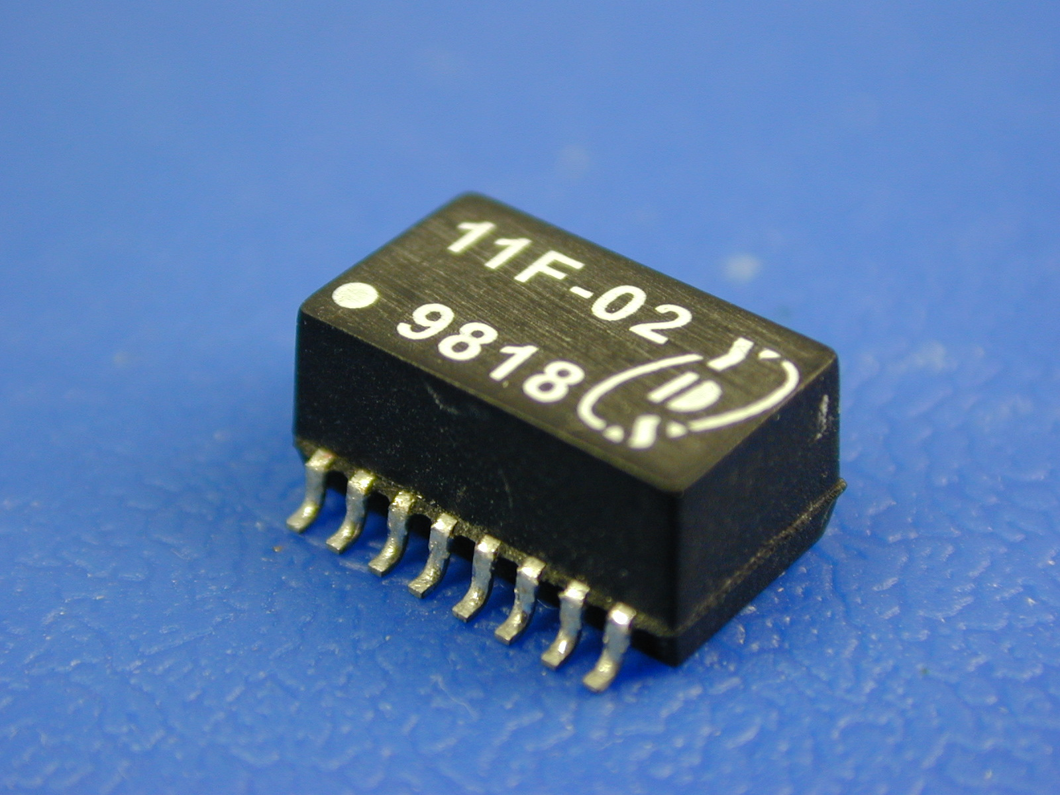
• Meet IEEE 802.3 and ANSI X3.263 standards including
350 uH OCL with 8mA Bias
• Desingned to withstand IR reflow temperatures up to 235∘C
• Compact footprint use in the most space restrictive applications
• Recognized by UL 1950.

ELECTRICAL SPECIFICATIONS @25℃-Operating temperature -40℃ TO 85℃
Part  Number | Turns Ratio  (±5%) |  | Insertion  Loss  (dB MAX) | Return Loss  (dB TYP) |  |  | Differential to Common  Mode Rejection  (dB MIN) |  |  |  | Crosstalk  (dB MIN) |  |  | Hipot  V_{rmS}  MIN
Part  Number | TX | RX | 0.1-100MHz | 30  MHz | 60  MHz | 80  MHz | 30  MHz |  | 50  MHz | 100  MHz | 30  MHz | 60  MHz | 100  MHz | Hipot  V_{rmS}  MIN
11F-05 | 1:1 | 1:1 | -1.1 | -20 | -14 | -11.5 | -42 |  | -37 | -33 | -45 | -40 | -35 | 1500
11F-06 | 1.25:1 | 1:1 | -1.1 | -20 | -14 | -11.5 | -42 |  | -37 | -33 | -45 | -40 | -35 | 1500
11F-07 | 2:1 | 1:1 | -1.1 | -20 | -14 | -11.5 | -42 |  | -37 | -33 | -45 | -40 | -35 | 1500
11F-08 | 1:1.414 | 1:1 | -1.1 | -18 | -12 | -11.5 | -42 |  | -37 | -30 | -45 | -40 | -35 | 1500
11F-09 | 1:1 | 1:1 | -1.0 | -18 | -14 | -12 | -40 |  | -40 | -40 | -35 | -35 | -35 | 1500
11F-10 | 1:1 | 1:1 | -0.9 | -18 | -12 | -11 | -40 |  | -35 | -30 | -45 | -45 | -37 | 1500
11F-11 | 1:1 | 1:1 | -1.0 | -20 | -14 | -12 | -42 |  | -37 | -32 | -45 | -40 | -35 | 1500
11F-12 | 1:1 | 1:1 | -1.0 | -20 | -14 | -12 | -42 |  | -37 | -32 | -45 | -40 | -35 | 1500
MECHANICAL

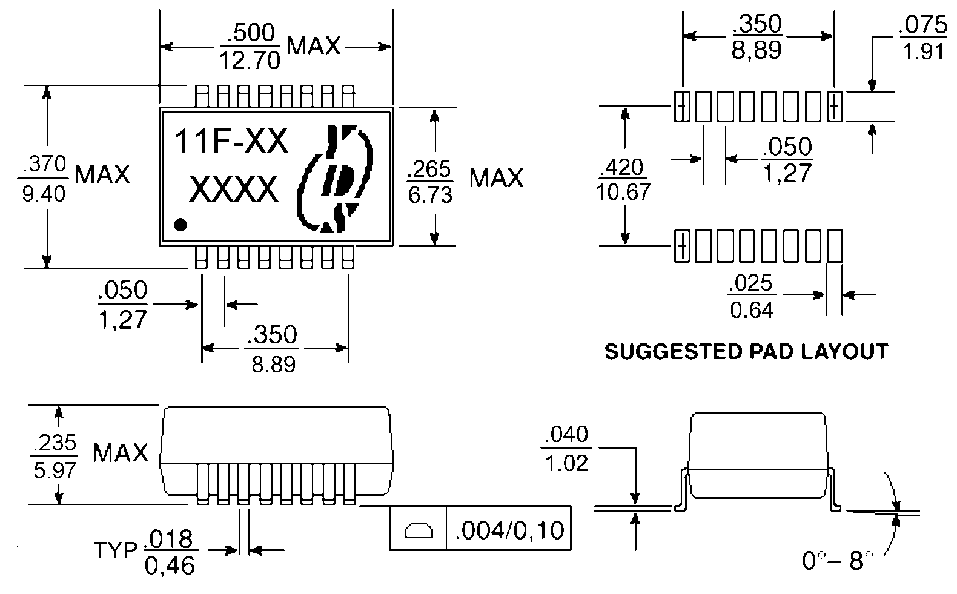

SCHEMATICS
11F-05, 06, 07  08, 11 | 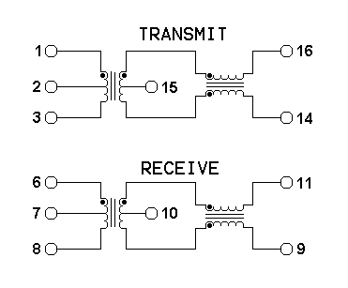
11F-10 | 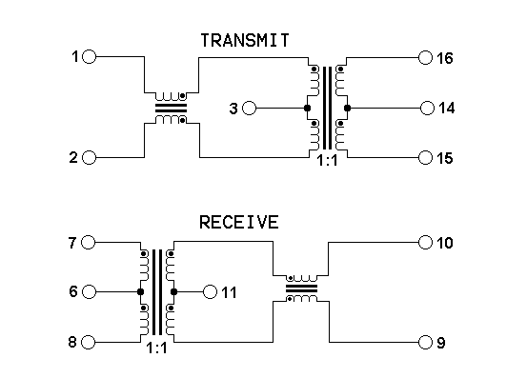
11F-09, 12 | 