 |  |  | 58T SERIES |  |  |  |  |  | T1/CEPT/ISDN-PRI TRANSFORMER
 |  |  |  |  |  |  |  |  | EIGHT TRANSJORMERS FOR QUAD T1/E1 PORTS
 | FEATURES |  |  |  |  |  |  |  |  |  |  | 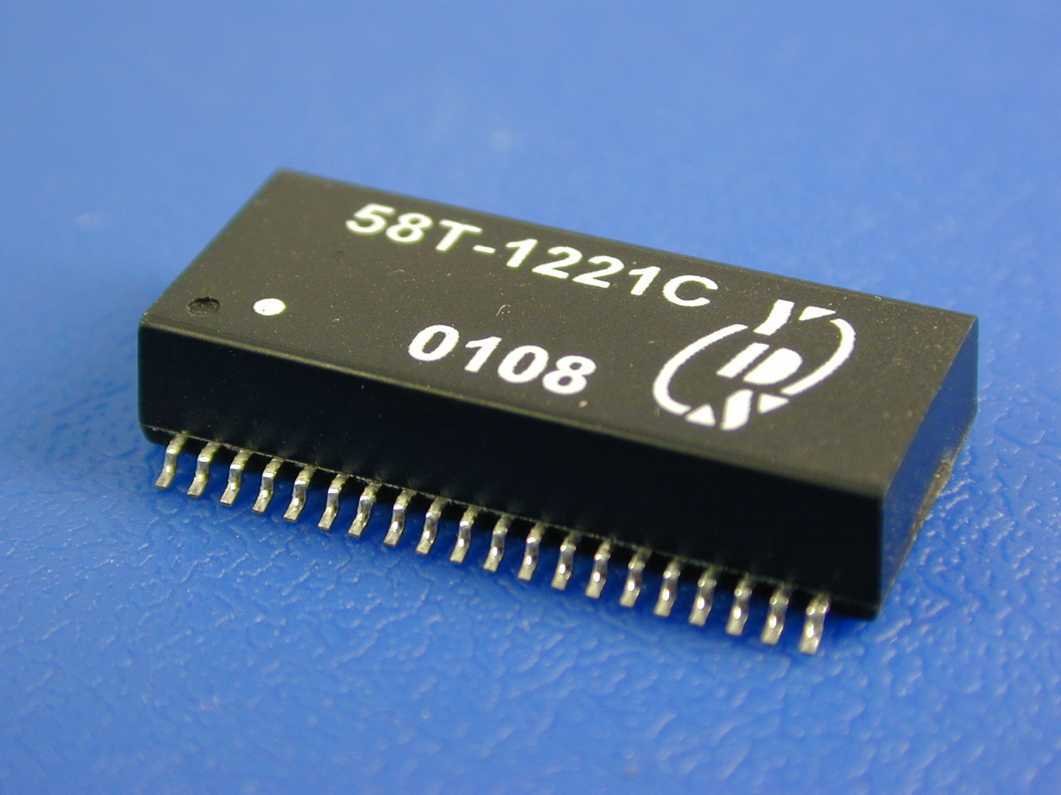
• EIGHT TRANSFORMERS IN A SURFACE MOUNT PACKAGE
SUPPORTS FOUR TRANSMIT AND FOUR RECEIVE
CHANNELS.
• CROSSTALK:-65dB OR BETTER.
• MODELS MATCHED TO LEADING QUAD AND DUAL
T1/E1/CEPT/ISDN-PRI TRANSCEIVERS.
• ISOLATION VOLTAGE:1500Vrms.
• RECOGNIZED BY UL 1950.
 | TEST CONDITIONS
 | • OCL -- 100KHZ/100mV |  |  |  |  | • LL-- 100KHZ/100mV |  |  |  |  |  | • Cww -- 100KHZ/100mV
 | ELECTRICAL SPECIFICATIONS @25℃
 | Part Number |  |  | Turns Ratio  (Pri:Sec±2%) |  |  | OCL @ 25℃  (mH MIN) |  |  | LL  (uH MAX) |  |  |  | Cww  (pF MAX) |  | Package  Schematic | Primary Pins
 | STD Temp. | EXT Temp. |  | Transmit | Receive |  | Transmit | Receive |  | Transmit | Receive |  |  | Transmit | Receive | Package  Schematic | Transmit | Receive
 | 58T-1221A | 58T-1221AC |  | 1 : 1.36 | 1:1.36CT |  | 1.2 | 1.2 |  | 0.6 | 0.6 |  |  | 35 | 35 | A | 1-2,6-7,11-12,16-17 | 38-36,33-31,28-26,23-21
 | 58T-1222A | 58T-1222AC |  | 1 : 1.14 | 1 :1.14CT |  | 1.2 | 1.2 |  | 0.6 | 0.6 |  |  | 35 | 35 | A | 1-2,6-7,11-12,16-17 | 38-36,33-31,28-26,23-21
 | 58T-1221C | 58T-1221CC |  | 1 : 2CT | 1 : 2CT |  | 1.2 | 1.2 |  | 0.8 | 0.8 |  |  | 35 | 35 | C | 4-5,9-10,14-15,19-20 | 24-25,29-30,34-35,39-40
 | 58T-1221D | 58T-1221DC |  | 1 : 2 | 1 : 2CT |  | 1.2 | 1.2 |  | 0.6 | 0.6 |  |  | 35 | 35 | D | 1-2,9-10,11-12,19-20 | 23-25,26-28,33-35,36-38
 | 58T-1222C | 58T-1222CC |  | 1 :1.36CT | 1 : 2CT |  | 1.2 | 1.2 |  | 0.6 | 0.6 |  |  | 35 | 35 | C | 24-25,29-30,34-35,39-40 | 4-5,9-10,14-15,19-20
 | 58T-1221B | 58T-1221BC |  | 1 : 2CT | 1 : 1CT |  | 1.2 | 1.2 |  | 0.6 | 0.6 |  |  | 35 | 35 | B | 1-2,6-7,11-12,16-17 | 21-22,26-27,31-32,36-37
 | 58T-1223C | 58T-1223CC |  | 1CT : 1.41 | 1CT:1.41 |  | 1.2 | 1.2 |  | 0.6 | 0.6 |  |  | 35 | 35 | C | 1-3,6-8,11-13,16-18 | 21-23,26-28,31-33,36-38
 | 58T-1223A | 58T-1223AC |  | 1 : 1.15 | 1 : 2CT |  | 1.2 | 1.2 |  | 0.6 | 0.6 |  |  | 35 | 35 | A | 1-2,6-7,11-12,16-17 | 21-23,26-28,31-33,36-38
 | 58T-1222B | 58T-1222BC |  | 1 : 1/1.26 | 1 : 2CT |  | 1.2 | 1.2 |  | 0.6 | 0.6 |  |  | 35 | 35 | B | 1-2,6-7,11-12,16-17 | 21-22,26-27,31-32,36-37
 | 58T-1221E | 58T-1221EC |  | 1 : 1.15 | 1 : 1.15 |  | 1.2 | 1.2 |  | 0.6 | 0.6 |  |  | 35 | 35 | E | 1-3,6-8,11-13,16-18 | 4-5,9-10,14-15,19-20
 | 58T-1222E | 58T-1222EC |  | 1 : 2 | 1 : 2 |  | 1.2 | 1.2 |  | 0.6 | 0.6 |  |  | 35 | 35 | E | 1-3,6-8,11-13,16-18 | 4-5,9-10,14-15,19-20
 | 58T-1225A | 58T-1225A |  | 1 : 1.08 | 1.08CT:1 |  | 1.2 | 1.2 |  | 0.4 | 0.5 |  |  | 35 | 35 | A | 1-2,6-7,11-12,16-17 | 38-36,33-31,28-26,23-21
 | 58T-1224C | 58T-1224CC |  | 1 : 2CT | 1CT : 2 |  | 1.2 | 1.2 |  | 0.6 | 0.6 |  |  | 35 | 35 | C | 4-5,9-10,14-15,19-20 | 1-3,6-8,11-13,16-18
 | 58T-1226A | 58T-1226A |  | 1 : 1.70 | 1:1.36CT |  | 1.2 | 1.2 |  | 0.8 | 0.6 |  |  | 35 | 35 | A | 1-2,6-7,11-12,16-17 | 21-23,26-28,31-33,36-38
 | 58T-1225C | 58T-1225C |  | 1 :1.36CT | 1 : 1.CT |  | 1.2 | 1.2 |  | 0.6 | 0.6 |  |  | 35 | 35 | C | 24-25,29-30,34-35,39-40 | 4-5,9-10,14-15,19-20
 | 58T-1022F | 58T-1022FC |  | 1 : 2.4 | 1 : 1 |  | 1.0 | 1.0 |  | 0.5 | 0.5 |  |  | 35 | 35 | F | 1-2,8-9,11-12,18-19 | 24-25,27-28,34-35,37-38
 | 58T-1023F | 58T-1023FC |  | 1 : 1.5 | 1.41 : 1 |  | 1.0 | 1.0 |  | 0.5 | 0.5 |  |  | 35 | 35 | F | 1-2,8-9,11-12,18-19 | 24-25,27-28,34-35,37-38
 | 58T-1021G | 58T-1021G |  | 1 : 2/2.4 | 1:0.79/1 |  | 1.0 | 1.0 |  | 1.0 | 1.0 |  |  | 35 | 35 | G | 1-2,9-10,11-12,19-20 | 37-36,35-34,27-26,25-24
 | 58T-1223E | 58T-1223E |  | 1 : 2.42 | 1 : 2.42 |  | 1.2 | 1.2 |  | 0.6 | 0.6 |  |  | 35 | 35 | E | 1-3,6-8,11-13,16-18 | 4-5,9-10,14-15,19-20
 | 58T-6013B | 58T-6013B |  | 1 : 2.1CT | 1 : 2.1CT |  | 1.2 | 0.6 |  | 0.6 | 0.6 |  |  | 35 | 35 | B | 1-2,6-7,11-12,16-17 | 21-22,26-27,31-32,36-37
 | 58T-6014B | 58T-6014B |  | 1 :2.45CT | 1:2.45C |  | 1.2 | 0.6 |  | 0.6 | 0.6 |  |  | 35 | 35 | B | 1-2,6-7,11-12,16-17 | 21-22,26-27,31-32,36-37
 | NOTE : Standard (STD) operating temperature range is 0°to 70℃. Extended (EXT) operating temperature range is -40°to 85℃.
 | MECHANICAL |  |  |  |  |  |  |  |  |  |  |  | SCHEMATICS
 | 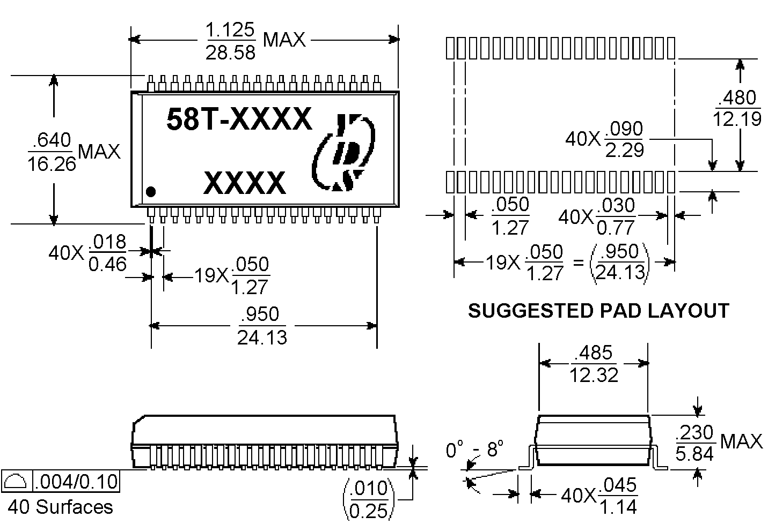 |  |  |  |  |  |  |  |  |  |  |  | 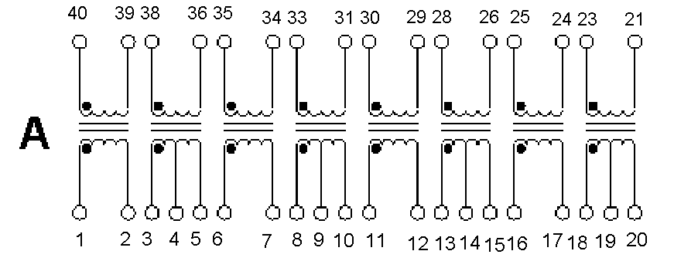
 | SCHEMATICS
 | 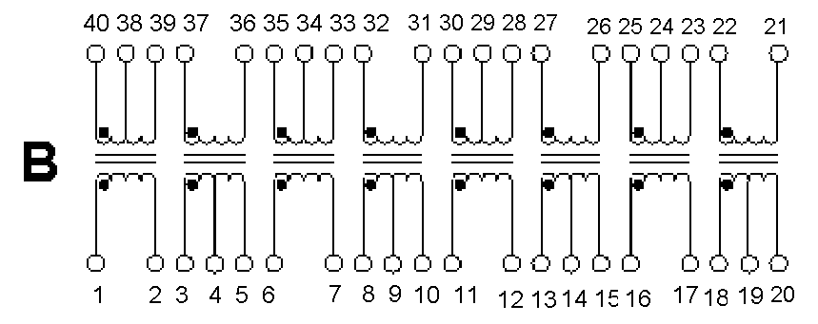 |  |  |  |  |  |  |  |  |  |  |  | 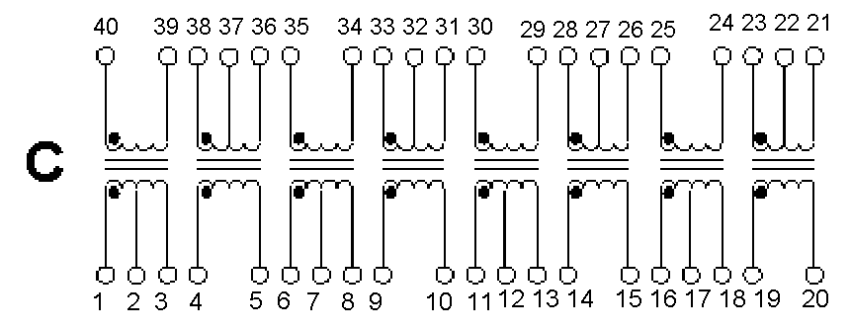
 | 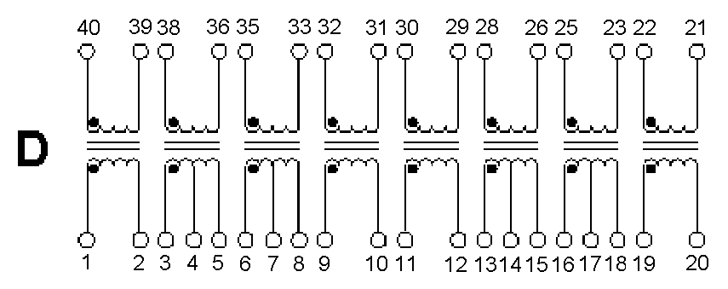 |  |  |  |  |  |  |  |  |  |  |  | 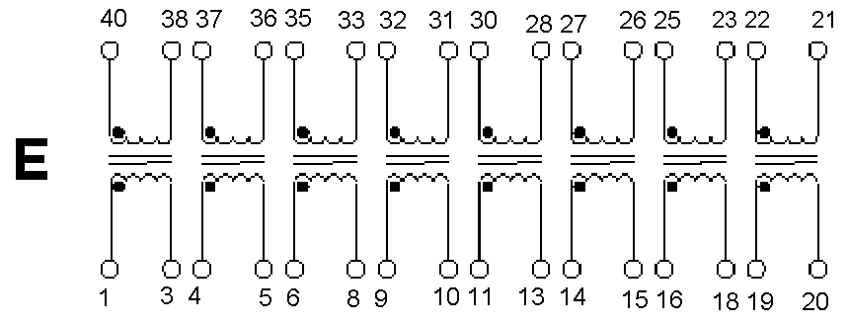
 | 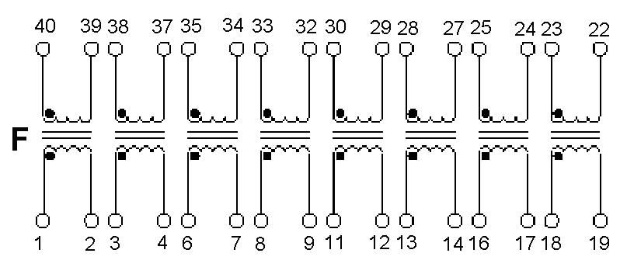 |  |  |  |  |  |  |  |  |  |  |  | 